History & Evolution of Linux? Linux Distributions (Ubuntu, CentOS, Debian, RHEL)? Understanding CLI vs GUI

Tasks
1.Open the terminal on your system and run the command 'uname -a' to display your Linux kernel version and system information. Take a screenshot of the output.
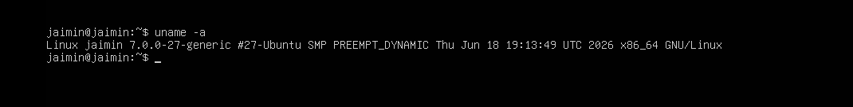

2.Research and list three key differences between Ubuntu, CentOS, and Debian Linux distributions, focusing on package management tools, default desktop environments, and typical use cases. Hint:-Look for terms like apt, yum, GNOME, KDE, server vs desktop usage.

Feature | Ubuntu | Debian | CentOS
Package Management Tool | Uses APT (Advanced Package Tool) to install, update, and remove software. | Uses APT, just like Ubuntu, to manage software packages. | Uses YUM (older versions) or DNF (newer versions) to install and manage software.
Default Desktop Environment | Uses GNOME by default. It has a modern and user-friendly interface. Other desktops like KDE and XFCE can also be installed. | Uses GNOME by default, but users can choose other desktop environments such as KDE, XFCE, or Cinnamon during installation. | Uses GNOME by default. It focuses more on stability than desktop appearance.
Typical Use Cases | Best for beginners, students, developers, and everyday desktop users. It is also used for cloud computing and servers. | Best for servers and users who need a very stable operating system. It is popular in web hosting and software development. | Best for businesses, enterprise servers, web servers, and databases. It is known for its security and long-term stability.
3.Switch between the CLI (terminal) and GUI (desktop environment) on your Linux system. Create a text file named 'my_linux_journey.txt' using both methods: first with the 'touch' command in CLI, then by right-clicking and creating a new text file in the GUI. Note which method you found faster and why.
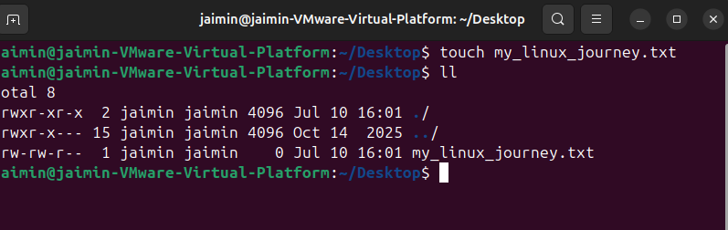
CLI (terminal)
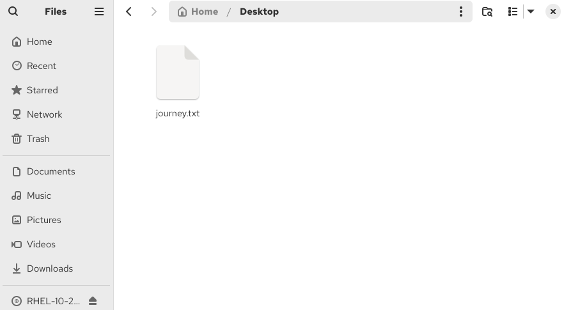
GUI (desktop environment)

I've made the file by both CLI and GUI. The CLI method was quick as I did not need to type in anything other than one command (touch my_linux_journey.txt) and press the Enter key. The GUI method was slower since I had to open the File Manager, right click, select "Desktop" and type in the file name. Thus, I opted for CLI method is more efficient and quick.

4.Imagine you are helping a friend who only uses GUI apps like Spotify and Zomato on their phone. Write a short guide (5-6 lines) explaining why learning the Linux CLI can be powerful for tasks like installing software, managing files, or troubleshooting issues.
The Linux CLI (Command Line Interface) allows you to operate the computer using commands. Many things—such as file management and software installation—go more quickly than through the GUI. Simple commands can be used to quickly copy, move, rename or remove files. The CLI is also quite handy when it comes to troubleshooting and solving system issues. The CLI is used to manage many servers and professional Linux systems. Basic computer knowledge and time saving by learning these linux commands.

